MODULE 12 – GRAPH (DEEP DIVE)
explained from basics → interview-advanced, pure Java, NO Collection Framework,
using array-based adjacency matrix & adjacency list, BFS & DFS, step-by-step logic, and dry-run thinking.
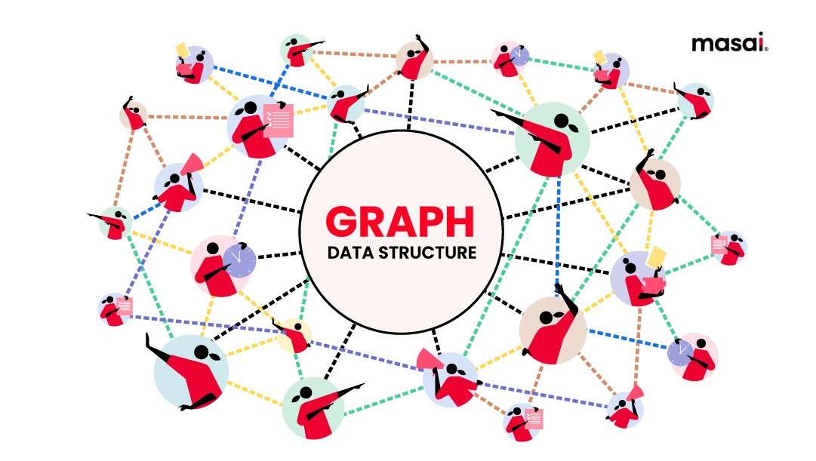
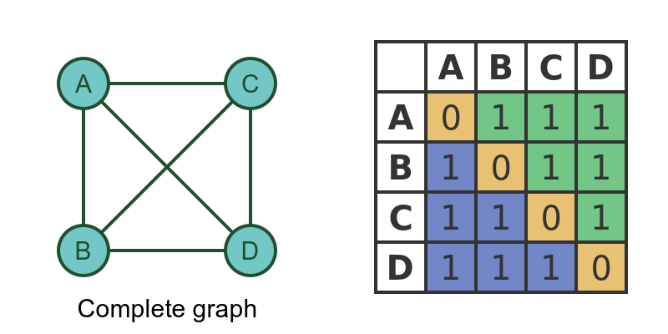
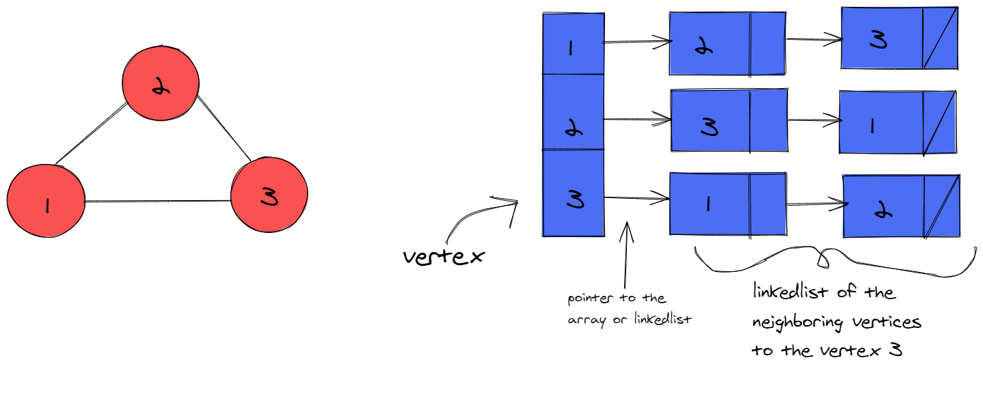
4

MODULE 12 – GRAPH DATA STRUCTURE

1. What is a Graph
- Graph is a non-linear data structure
- Consists of:
  - Vertices (nodes)
  - Edges (connections)
Meaning
Graph represents relationships between entities.

2. Real-Life Examples
- Social networks
- Road maps
- Computer networks
- Dependency graphs
- Web pages (links)

A
B C
D E

3. Graph Terminology (INTERVIEW MUST)
- Vertex (Node)
- Edge
- Degree
- Path
- Cycle
- Connected graph
- Disconnected graph

4. Types of Graphs
- Directed graph
- Undirected graph
- Weighted graph
- Unweighted graph

5. Graph Representation (VERY IMPORTANT)
Two main ways:
- Adjacency Matrix using array
- Adjacency List using list

🔹 ADJACENCY MATRIX

6. Adjacency Matrix – Definition
- 2D array representation
- matrix[i][j] = 1 if edge exists

7. Adjacency Matrix – Structure
class GraphMatrix {
int[][] adj;
int vertices;

GraphMatrix(int v) {
vertices = v;
adj = new int[v][v];
}
}

8. Add Edge (Undirected)
void addEdge(int u, int v) {
adj[u][v] = 1;
adj[v][u] = 1;
}

9. Print Matrix
void printGraph() {
for (int i = 0; i < vertices; i++) {
for (int j = 0; j < vertices; j++) {
System.out.print(adj[i][j] + " ");
}
System.out.println();
}
}

10. Adjacency Matrix – Complexity
- Space → O(V²)
- Edge lookup → O(1)
- Best for dense graphs

ADJACENCY LIST (ARRAY BASED)

11. Why Adjacency List
- Saves space
- Efficient for sparse graphs

12. Array-Based Adjacency List
(No Collection Framework)
class GraphList {
int[][] adjList;
int[] sizes;
int vertices;
int maxEdges;

GraphList(int v, int maxEdges) {
vertices = v;
this.maxEdges = maxEdges;
adjList = new int[v][maxEdges];
sizes = new int[v];
}
}

13. Add Edge (Undirected)
void addEdge(int u, int v) {
adjList[u][sizes[u]++] = v;
adjList[v][sizes[v]++] = u;
}

14. Print Adjacency List
void printGraph() {
for (int i = 0; i < vertices; i++) {
System.out.print(i + " -> ");
for (int j = 0; j < sizes[i]; j++) {
System.out.print(adjList[i][j] + " ");
}
System.out.println();
}
}

15. Adjacency List – Complexity
- Space → O(V + E)
- Edge lookup → O(deg(V))
- Best for sparse graphs

🔹 GRAPH TRAVERSALS (INTERVIEW FAVORITE)

16. Breadth First Search (BFS)
Idea
- Visit neighbors first
- Level-by-level traversal
- Uses Queue (array-based)

17. BFS Using Array Queue
void bfs(int start) {
boolean[] visited = new boolean[vertices];
int[] queue = new int[vertices];
int front = 0, rear = 0;

visited[start] = true;
queue[rear++] = start;

while (front < rear) {
int node = queue[front++];
System.out.print(node + " ");

for (int i = 0; i < sizes[node]; i++) {
int adjNode = adjList[node][i];
if (!visited[adjNode]) {
visited[adjNode] = true;
queue[rear++] = adjNode;
}
}
}
}

18. BFS Dry Run Example
Graph:
0--1
| |
2--3
BFS from 0:
0 → 1 → 2 → 3

19. BFS Use Cases
- Shortest path (unweighted graph)
- Level order traversal
- Network broadcasting

🔹 DEPTH FIRST SEARCH (DFS)

20. DFS – Idea
- Go as deep as possible
- Backtrack
- Uses recursion (implicit stack)

21. DFS Using Recursion
void dfs(int node, boolean[] visited) {
visited[node] = true;
System.out.print(node + " ");

for (int i = 0; i < sizes[node]; i++) {
int adjNode = adjList[node][i];
if (!visited[adjNode]) {
dfs(adjNode, visited);
}
}
}

22. DFS Driver
void startDFS(int start) {
boolean[] visited = new boolean[vertices];
dfs(start, visited);
}

23. DFS Dry Run
Graph:
0--1
| |
2--3
DFS from 0:
0 → 1 → 3 → 2

24. DFS Use Cases
- Cycle detection
- Topological sorting (concept)
- Maze solving
- Connectivity check

🔹 ADVANCED GRAPH CONCEPTS (INTERVIEW THEORY)

25. Connected Components
- Count how many DFS/BFS calls needed
- Each call = one component

26. Cycle Detection (Undirected Graph)
Concept:
- DFS with parent tracking

27. Directed Graph Traversal
- Edge is one-way
- Only add u → v

28. Graph vs Tree
- Graph
  - Can have cycles
  - Multiple paths
- Tree
  - No cycles
  - Single root

29. Time Complexity Summary
- BFS → O(V + E)
- DFS → O(V + E)
- Matrix space → O(V²)
- List space → O(V + E)

30. Common Interview Questions
- BFS vs DFS?
- Adjacency matrix vs list?
- Detect cycle?
- Connected components?
- BFS shortest path?

WHAT IS DIJKSTRA ALGORITHM?
Definition
Dijkstra Algorithm is used to find the shortest path (minimum cost/distance) from a source node to all other nodes in a weighted graph (no negative weights).
In simple words:
It finds the cheapest / shortest route.

Flight Booking Systems

Cities = Nodes
Flights = Edges
Ticket Price = Weight
Finds cheapest flight

HOW IT WORKS (INTUITION)
Idea:
- Start from source
- Always pick minimum distance node
- Update neighbors
- Repeat

HOW IT WORKS (INTUITION)
Idea:
- Start from source
- Always pick minimum distance node
- Update neighbors
- Repeat

